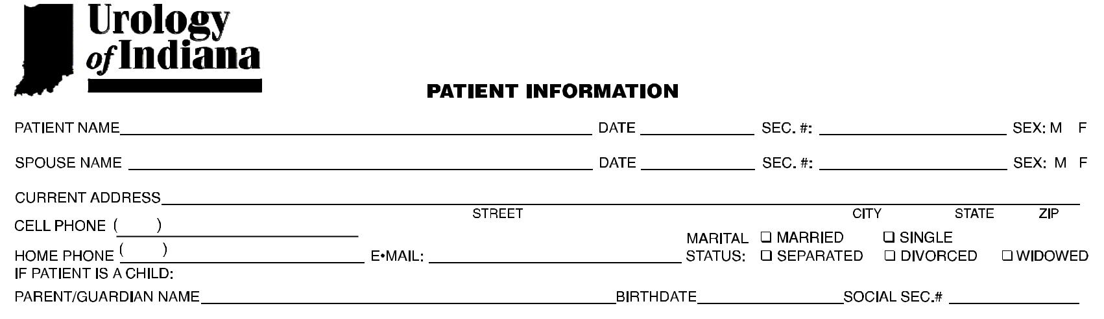**PATIENT REGISTRATION FORM**

*Please answer all questions to the best of your ability*

BIRTH SOCIAL

BIRTH SOCIAL

ADDRESS_______________________________________________________________________________________ PHONE______________________________



ADDRESS (IF DIFFERENT)_________________________________________________________________________ PHONE (IF DIFFERENT)________________

NAME:___________________________ PHONE:________________



3.__________________________________ BIRTH DATE__________ SEX:___



4.__________________________________ BIRTH DATE__________ SEX:___

